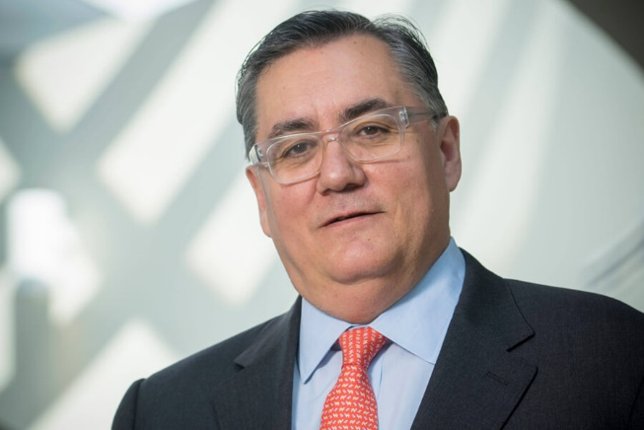**Tomás Díaz de la Rubia** is Purdue University’s chief scientist and executive director of [Discovery Park](http://www.purdue.edu/discoverypark). In this position, his responsibilities include building upon Discovery Park’s foundation of excellence which has enabled high-impact research that crosses traditional academic boundaries. He works closely with the faculty and deans to help catalyze Purdue’s many strengths and build on its legacy of interdisciplinary research with global impact. He is also a professor of Materials Science, and of Strategic Management (by Courtesy) in the Krannert School of Management.

Before coming to Purdue, Díaz de la Rubia served as innovation leader and a director in Deloitte's energy and resources industry practice in Washington, D.C., working with Fortune 500 energy and manufacturing companies to identify and capitalize on business opportunities arising from potentially disruptive, innovative new technologies.

Prior to joining Deloitte, Tomás was the chief research officer and deputy laboratory director for science and technology at the Lawrence Livermore National Laboratory (LLNL) in California, where he was responsible for the long-term health of the science and technology foundations of the laboratory’s $1.6 billion research program. In this capacity, he oversaw a $300M program of basic and applied research, and was responsible for the Laboratory’s industrial partnerships and technology commercialization. From 2002-2009, he was an associate director at LLNL, leading its chemistry, materials science, life sciences, and energy and environmental sciences organizations, as well as its $60 million basic materials science, chemistry and biology programs with the Department of Energy's Office of Science.

Tomas is a member of the National Academies of Sciences, Engineering and Medicine Intelligence Community Studies Board, which discusses science and technology issues of importance to the nations’ intelligence community. Tomas also serves as a member of the Board of Directors of the Civilian Research and Development Foundation (CRDF Global), a non-profit organization dedicated to promoting peace and prosperity through international scientific collaboration, and as a member of the Editorial Board of Applied Physics Reviews. Among his hobbies, he is a member of the Confrerie des Chevaliers du Tastevin, a worldwide group dedicated to promoting the virtues of the wines and foods of Burgundy.

Díaz de la Rubia has published more than 150 peer-reviewed articles and has co-edited several books and conference proceedings. He is a fellow of the American Physical Society and of the American Association for the Advancement of Science and served as an elected member of the board of directors of the Materials Research Society, and vice-chair of the division of computational physics of the American Physical Society. He holds a bachelor's degree (summa cum laude) and a doctorate in physics from The State University of New York, Albany.